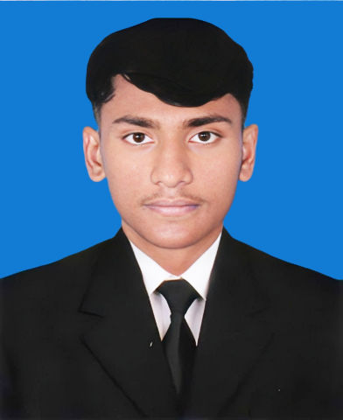 |  | EDUCATION
Diploma in Computer Science & Technology (Current 6th Semester)
[IMB Polytechnic Institute]
[2022 – 2026] (Expected Completion)
Highlights: Currently focusing on core concepts of Programming, Basic Networking, and Software Applications…

[Mirpur Adarsha Bidyatan]
[2020 ]– [2022]
Group - Humanities
GPA – 3.67
shamim islam  Profile  A highly motivated and versatile Diploma student in Computer Science & Technology, eager to leverage foundational IT knowledge combined with practical skills in Data Entry, Adobe Illustrator, and basic Electrical work. Seeking a challenging full-time or part-time role, especially in an international environment, to contribute strong problem-solving abilities and a commitment to continuous learning  CONTACT  PHONE:  +8801580314623  +8801570214623  LINKEDIN  http://www.linkedin.com/in/shamim-islam-850524342  EMAIL:  shamimislam322560@gmail.com |  | WORK EXPERIENCE
[ RISE FASHION ] [Computer Front Desk Officer]
[2022–2023]
* Managed daily administrative tasks at the front desk using MS Word and MS Excel. * Utilized MS Excel skills for data management and basic reporting needs. * Assisted in creating and editing basic promotional graphics using graphics software. * Maintained effective communication between customers and internal teams.

Language | Proficiency Level
Bengali | Native (Fluent)
English | Proficient (Writing, Speaking, Comprehension
Hindi/Urdu | Conversational Fluency
Japanese | Beginner (Currently Learning)

LANGUAGE PROFICIENCY
 |  | SKILLS
Category | Specific Skills
IT & Software | Data Entry (Fast & Accurate), Microsoft Office Suite (Word, Excel, PowerPoint), Basic Programming Logic (as per Diploma curriculum).
Graphic Design | Adobe Illustrator: Proficient in vector graphics, basic logo design, and print material preparation.
Technical | Basic knowledge and practical experience in Electrical Wiring and Installation.
Other | Driving proficiency, Time Management, Strong Work Ethic, Quick Learner.

